St. Michael and All Angels | 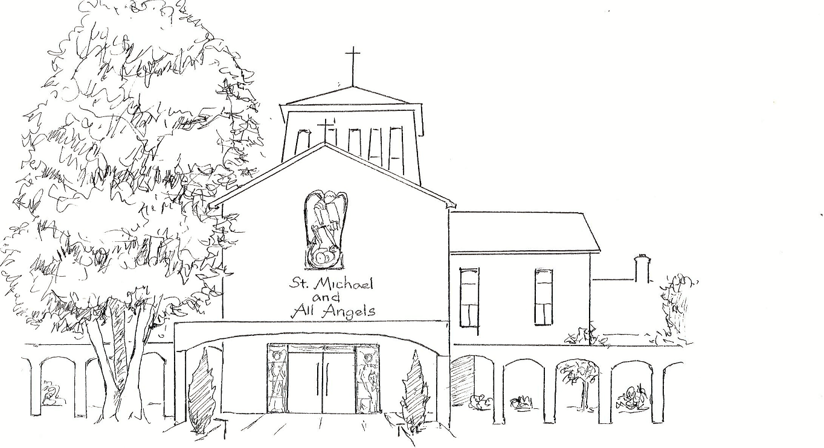 | Amersham on the Hill



A Service of Lament, Thanksgiving and Restoration

The coronavirus pandemic has resulted in many cases of severe illness and a large number of deaths. People are grieving the loss of loved ones; we are lamenting the pain and anxiety that so many are experiencing; we are also giving thanks for the courage and generous spirit of care that is transforming whole communities; and wanting to gather in prayer to the God who sustains us through trauma and offers hope of restoration and renewal.
This service gives us an opportunity to remember those, who have died and those still suffering; all whose employment and education has been adversely effected and those still shielding. Now that restrictions have been eased, it gives us an opportunity to pray to God for healing, as we look to the future and hope for a return to some form of normality. It also allows us to give thanks for all those both nationally and in our own local communities, who have worked so hard in our hospitals and care homes, and for all who in many different ways, have helped people by shopping, collecting medication or by fundraising, and those, who have been involved in the vaccination programme. We come together to thank God for our deliverance and to look with hope to the future.

Welcome and Introduction

Welcome to this service of Lament, Thanksgiving and Restoration, being held in relation to the Covid 19 pandemic. During this service there will be opportunities if you so wish, to participate in naming loved ones who have died and also to offer thanks on our Rainbow wall of ‘Remembrance and Thanksgiving’. There will also be opportunity to light candles of hope for Restoration. These resources are there for you, but please do not feel that you have to engage with them if you do not wish, just do or do not, as feels appropriate to you. This service is offered with humility and love, praying that whether you are Christian, a different faith, or of no faith, you may find within what is offered a sense of grace and peace.

The Lament Please remain seated for the service.

Quiet music

A time to collect our thoughts

The Gathering

We meet in the presence of God
All who knows our cries,
feels our pain,
and heals our wounds.

Lord God, the maker and redeemer of all
as we come before you
in grief and praise this day,
comfort us with your presence,
make us attentive to your voice,
And sustain us with hope of your kingdom;
through Jesus Christ our Lord.
All Amen.

Free us God of mercy,
from all that keeps us from you;
relieve the misery of the anxious and the bereaved,
and fill us with the hope of peace;
through Jesus Christ our Lord.
All Amen

O Christ, Son of the living God,
help us when we are too cast down to pray,
and grant that we may trust you all our days,
for you are with us in our living and our dying,
Jesus, Lord and God.
All Amen

In the darkness of unknowing,
when your love seems absent,
draw near to us, O God,
in Christ forsaken,
in Christ risen,
our Redeemer and our Lord.
All Amen

‘The Last Journey’ – Sung by the choir.

Father we commend to your faithful love
those who are crying from the depths;
help them to watch and pray
through their time of darkness,
in sure hope of the dawn of your forgiveness and redemption;
through Jesus Christ our Lord.
All Amen

Reading- Psalm 23

Read by a local funeral director representing all funeral directors in supporting the bereaved in such difficult circumstances.

The Lord is my shepherd, I shall not want,
He makes me lie down in green pastures;
he leads me beside still waters;
he restores my soul.
He leads me in right paths for his name’s sake.
Even though I walk through the darkest valley,
I fear no evil;
for you are with me;
your rod and your staff, they comfort me.
You prepare a table before me
in the presence of my enemies;
you anoint my head with oil;
my cup overflows.
Surely goodness and mercy shall follow me
all the days of my life,
and I shall dwell in the house of the Lord
my whole life long.

Quiet Music

Within your service book there is a purple butterfly shaped card. If you would like to, write the names of loved ones who have died during the pandemic period or write anything that you feel a sense of loss for either through Covid or another reason. Or You may even like to write a message on it too. During the following hymn, baskets will be passed around to collect them and they will be placed on the rainbow.


Hymn – Be Still, My Soul

All Be still, my soul: the Lord is at your side;
bear patiently the cross of grief and pain;
leave to your God to order and provide;
in every change he faithful will remain.
Be still my soul: your best, your heav’nly friend,
through thorny ways, leads to a joyful end.

Be still, my soul: your God will undertake
to guide the future as he has the past.
Your hope, your confidence let nothing shake,
all now mysterious shall be clear at last.
Be still, my soul: the tempests still obey
His voice, who ruled them once on Galilee.

Be still, my soul: the hour is hastening on
When we shall be for ever with the Lord,
When disappointment, grief and fear are gone,
Sorrow forgotten, loves pure joy restored.
Be still, my soul: when change and tears are past,
all safe and blessed we shall meet at last.

Thanksgiving

Verses from Psalm 46

The Lord is with us, He is our stronghold;
All God will help us at the break of day.

God is our refuge and strength,
ready to help whenever we are in trouble:
All God will help at the break of day.

We will not fear, even if the earth shakes,
and the mountains topple into the sea:
All God will help at the break of day.

Come now and look at the works of the Lord,
the awesome things he has done on earth:
All God will help at the break of day.

Be still and know that I am God;
I will be exalted among the nations:
I will be exalted in the earth:
All God will help at the break of day.

Glory to the Father and to the Son, and to the Holy Spirit.
All The Lord is with us, He is our stronghold;
God will help us at the break of day.

Reading - Matthew 25: 34 – 39.

Read by a representative of all those who delivered, and continue to deliver, groceries and medicines to the vulnerable.

Then the king will say to those at his right hand, “Come, you that are blessed by my Father, inherit the kingdom prepared for you from the foundation of the world; for I was hungry and you gave me food, I was thirsty and you gave me something to drink, I was a stranger and you welcomed me, I was naked and you gave me clothing, I was sick and you took care of me, I was in prison and you visited me.’ Then the righteous will answer him, ‘Lord, when was it that we saw you hungry and gave you food, or thirsty and gave you something to drink? And when was it that we saw you a stranger and welcomed you, or naked and gave you clothing. And when was it that we saw you sick or in prison and visited you? And the king will answer them, “Truly I tell you, just as you did it to one of the least of these who are members of my family, you did it to me.’

Quiet Music

Within your service book there is an orange butterfly shaped card. If you would like to, write the name or names of individuals or an organisation that you would especially like to thank for their help to you or the nation during the pandemic. During the following hymn, baskets will again be passed around to collect them and they too will be placed on the rainbow.



Hymn – When I needed a neighbour.

When I needed a neighbour, were you there were you there?
When I needed a neighbour where you there?

And the creed and the colour and the name won’t matter,
Were you there? (Repeat after each verse)

I was hungry and thirsty, were you there were you there?
I was hungry and thirsty, were you there?

When I needed a shelter, were you there, were you there?
When I needed a shelter, were you there?

Wherever you travel I’ll be there I’ll be there,
Wherever you travel I’ll be there.

And the creed and the colour and the name won’t matter,
I’ll be there.

Restoration

Trust in the Lord with all your heart;
And be not wise in your own sight.
All Trust in the Lord with all your heart;
and be not wise in your own sight.

In all your ways acknowledge him
and he will make straight your paths.
All Trust in the Lord with all your heart.

Glory to the Father, and to the Son, and to the Holy Spirit.
All Trust in the Lord with all your heart;
and be not wise in your own sight.

Reading - 1 Corinthians 13. 4-13

Read by a representative of our Emergency Services

Love is patient and kind, love is not jealous or boastful, it is not arrogant or rude.
Love does not insist on its own way, it is not angry or resentful.
It does not rejoice in wrongdoing but rejoices in the truth.
Love bears all things and believes all things; love hopes all things and endures all things.
Love will never come to an end, but prophecy will vanish, tongues will cease and knowledge pass away.
Know we know only in part and we prophesy only in part,
But when the perfect comes, the partial shall pass away.
When I was a child, I spoke like a child, I thought like a child, I reasoned like a child.
But when I became mature, I put an end to childish ways.
For now we see only puzzling reflections in a mirror, but then we see face to face.
Now I know only in part;
Then I shall know fully, even as I have been fully known.
There are three things that last forever, faith, hope and love, but the greatest of these is love.

Prayers for Restoration and Hope.

God the Father, your will for all people is health and
salvation.
Lord, grant your healing grace to all who are sick,
and to all who are lonely, anxious or depressed an
awareness of your presence.
Mend broken relationships, and restore to those in distress
soundness of mind and serenity of spirit.
Sustain and support those who seek your guidance and lift
up those who are brought low by the trials of this life.
Grant to the dying peace and uphold by the grace and
consolation of your Holy Spirit those who are bereaved.
You are the Lord who does mighty wonders.

With you, Lord, is the well of life
All and in your light do we see light.
Hear us, Lord of life:
All heal us, and make us whole.

May God in his infinite love and mercy
bring the living and departed in the Lord Jesus,
to a joyful resurrection and the fulfillment of his eternal kingdom.
All Amen.

Hymn

Let there be love shared among us,
Let there be love in our eyes.
May now your love sweep this nation;
Cause us, O Lord, to arise.
Give us a fresh understanding,
brotherly love that is real.
Let there be love shared among us,
Let there be love.

Let there be peace shared among us,
Let there be peace in our eyes.
May now your peace sweep this nation;
Cause us, O Lord to arise.
Give us a fresh understanding,
Sisterly love that is real.
Let there be peace shared among us,
Let there be peace.

Let there be hope shared among us,
Let there be hope in our eyes.
May now your hope sweep this nation;
Cause us, O Lord, to arise.
Give us a fresh understanding,
Brotherly love that is real.
Let there be hope shared among us,
Let there be hope.

Let there be joy shared among us,
Let there be joy in our eyes.
May now your joy sweep this nation;
Cause us, O Lord, to arise.
Give us a fresh understanding,.
Sisterly love that is real.
Let there be joy shared among us,
Let there be joy.

Let there be love shared among us,
Let there be love in our eyes.
May now your love sweep this nation;
Cause us, O Lord, to arise.
Give us a fresh understanding,
brotherly love that is real.
Let there be love shared among us,
Let there be love.

Moving Forward in Hope

We do hope and pray that you have found that this service has been of some help to you. And we pray blessings and peace for you, your families and friends in what ever form that feels appropriate to you.

After the blessing if you would like to enter the church and light a candle as a sign of hope for the future, you are very welcome to do so, There are plenty of candles available positioned within the cross of candles, also candle stands are all around the church. If you would prefer to light a candle outside there are plenty of candle jars too.

We conclude this service with a blessing following ‘Prayer for Today’ by Winifred Brand.

Read by a representative of all Care Home workers..

Lord, give me strength just for today
To do the tasks that come my way,
To say the word, to think the thought
With which real strength of soul is wrought.

Lord, give me courage to resist
The urge to worry and persist
In borrowing from future years
Troubles unknown or futile tears.

Just for today, Lord, let me find
True strength and faith and peace of mind;
And I will for tomorrow pray
When it becomes a new today.

Blessing

May Christ,
who out of defeat brings a new hope and a new future,
fill you with his new life;
and the blessing of God almighty,
the Father, the Son, and the Holy Spirit,
be with you and all those whom you love,
wherever they may be, now and for all eternity.
All Amen.

Go in the peace of Christ
All Thanks be to God.



Choir – All Shall Be Well

If you would like to talk to someone or would like to know more about
St. Michael’s services and activities then please do contact us.
Parish Office Tel- 01494 726680 or
via our website www.stmichaelsamersham.org.uk

The Liturgical Commision – Marking our Communities 2. The Promise of His Glory (1991), Patterns for Worship (1995), Common Worship: Services and Prayers for the Church of England (2000), New Patterns for Worship (2002) and Times and Seasons (2006),
Enriching the Christian Year, (1993), material from which is included in this service, is copyright © The Archbishops’ Council. CCL No 908682.
SM&AA 2021

